Chemistry Unit C1: Structures, Trends, Chemical Reactions, Quantitative Chemistry and Analysis
C1.5 Symbols, formulae and equations
Content - CCEA Double Award Chemistry 1 – Fort Hill Integrated College | Got it | Nearly | Haven’t a clue
C1.5 Symbols, formulae and equations
Can you recognise symbols and names for common elements and recall the diatomic elements;
Can you interpret chemical formulae by naming the elements and stating the number of each type of atom present;
Can you write chemical formulae of compounds;
Can you demonstrate understanding that chemical reactions use up reactants and produce new substances called products;
Can you construct word equations to describe the range of reactions covered in this specification;
Can you recognise that in a chemical reaction no atoms are lost or made but they are rearranged, and as a result we can write balanced symbol equations showing the atoms involved;
Can you write balanced symbol equations for all reactions covered in this specification and for unfamiliar chemical reactions when the names of the reactants and products are specified;
Can you write balanced ionic equations for reactions, including reactions covered in this specification;
Can you write half equations for reactions covered in this specification where appropriate;
Can you demonstrate knowledge and understanding that in chemical equations the three states of matter are shown as (s), (l) and (g), with (aq) for aqueous solutions, and include appropriate state symbols in equations for the reactions in this specification.

C1.5 Symbols, formulae and equations

Elements - consist of one type of atom. Every element has a symbol beginning with a capitol letter.

Diatomic molecules are 2 identical atoms covalently bonded together e.g. O₂ N₂ H₂ F₂ Cl₂ Br₂ I₂

Compounds – 2 or more elements chemically combined

Interpreting formulae
Formula of compound | Name of compound | Elements present | Number of each element
CO₂
CO
H₂O
CaCO₃
NH₃
HCl
HNO₃
H₂SO₄

Sometimes a formula includes brackets. This means the atoms inside the brackets are multiplied by the number outside the brackets (exactly the same as in maths). E.g. ammonium sulphate

 |  | 3 x 4 – 12 atoms of oxygen
 | Al₂(SO₄)₃
2 atoms of aluminium |  | 3 atoms of sulfur

Formula | Atoms present
HNO₃ | 1 atom Hydrogen | 1 atom Nitrogen | 3 atoms oxygen
Ca(OH)₂
Cu(NO3)₂
H₃PO₄
Fe₂(CO₃)₃

Ion charges
Each Group in the Periodic table forms an ion with a different charge;
Group | Charge on cation |  | Group | Charge on anion
1 |  |  | 5
2 |  |  | 6
3 |  |  | 7

The charges of any Transition metal ions you need to know are provided on the data leaflet. So are those of the molecular ions (charged particles containing more than one element).

Test yourself
- What is the symbol of the following elements?
Potassium | Sulphur | Calcium
Phosphorus | Fluorine | copper
Silicon | Zinc | sodium

- Name four diatomic gases in the Periodic Table and write their formulae.
…………………………………………………………………………………………………………………

- Write the charge of the following ions:
chloride | oxide | Sulphide
nitride | aluminium | Magnesium
phosphide | Sulfate | Carbonate
dichromate | ethanoate | Lithium
Iron (II) | Ammonium | hydroxide

C1.5 Symbols, formulae and equations

Ionic formula
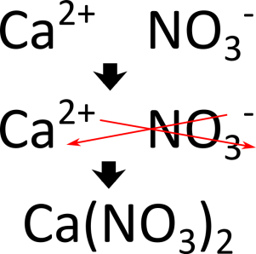
The chemical formula of a compound tells us both the ………………… involved and also the simplest ……………….. of these elements in the compound. The ratio of the elements depends on how many ……………………… are needed to complete the outer shells. For ionic compounds we can work out the formula using the ‘……………. ………. ……..….’ rule. We use the ……………….. number (the number of electrons an atom can lose, gain or share).
What is the chemical formula for the following Ionic compounds?
- Potassium chloride
- Aluminium sulphide
- Calcium nitrate
- Sodium sulfate
- Copper (II) sulfate
- Aluminium dichromate
- Magnesium hydroxide
- Silver nitrate
Equations
Chemical reactions – we can describe what is happening in a chemical reaction using equations. These can be written as words or symbols. In chemical equations the three states of matter are shown as (s), (l) and (g), with (aq) for aqueous solutions
reactant product
In a chemical reaction no atoms are lost or made (this means the mass on both sides is the same) but they are rearranged, and as a result we can write balanced symbol equations showing the atoms involved.
Examples
- Combustion of Magnesium
Magnesium + Oxygen Magnesium oxide
Mg_{(s)} + O_{2 (g)} MgO_{(s)}

- Magnesium and Acid
Magnesium + Hydrochloric acid

- Combustion of Methane
Methane + Oxygen

- Potassium and Water
Potassium + Water

- Neutralisation
Hydrochloric acid + Sodium Hydroxide

Balancing equations
In a chemical reaction no atoms are lost or made but they are rearranged. This means that chemical equations have equal numbers of each atom on each side of the equation.
CaCO₃ |  | CaO + CO₂
1 | Ca | 1
1 | C | 1
3 | O | (1+2) = 3

When balancing equations, you can only add BIG numbers (you can’t mess about with the _{little numbers})
Test yourself
Balance the following equations
- Mg + N₂ Mg₃N₂
- Na + O₂ Na₂O
- Ca(OH)₂ + NH₄Cl CaCl₂ + NH₃ + H₂O
- SO₂ + O₂ SO₃
- Fe + O₂ Fe₂O₃
- C₂H₆ + O₂ CO₂ + H₂O
- Na + Cl₂ NaCl
- Pb + O₂ Pb₃O₄
- Zn + HCl ZnCl₂ + H₂
- KHCO₃ + H₂SO₄ K₂SO₄ + CO₂ + H₂O

Ionic equations (Higher tier)

Ionic compounds consist of positive ions and negative ions strongly bonded together in a lattice. When an ionic compound dissolves in water the lattice breaks up and the ions separate out and become surrounded by water molecules.

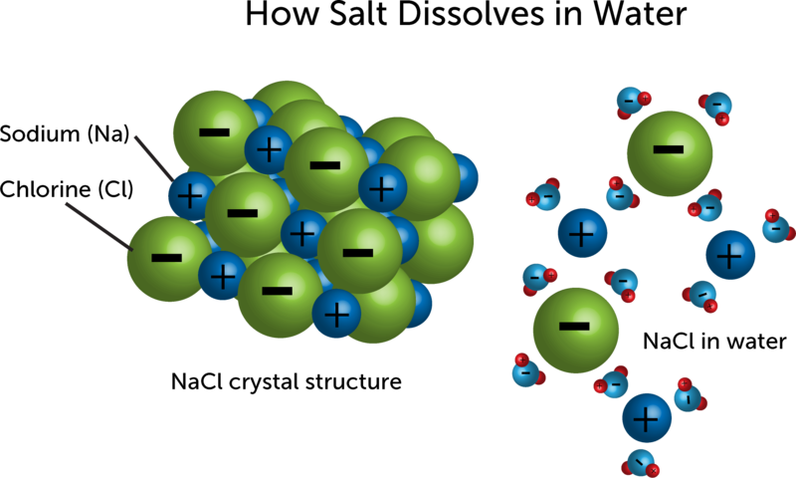

When dissolved, ionic compounds react. However, only some of the ions react; others do not react and remain unchanged. These ions are called spectator ions. Spectator ions are ions that do not take part in a reaction and are not shown in the ionic equation for the reaction.
Ionic equations only show what happens to the ions that react. Ionic equations can be written for different types of reactions:
- Neutralisation
- Precipitation (Yr12)
- Displacement

- Neutralisation

H⁺ _{(aq)} + OH⁻_{(aq)} H₂O_{(l)}

- Displacement – when a more reactive metal displaces a less reactive metal from a metal compound.
e.g. magnesium added to copper (II) sulfate

Mg_{(s)} + Cu²⁺_{(aq)} Cu_{(s)} + Mg²⁺_{(aq)}

Test yourself
Write an ionic equation with state symbols, for each of the following reactions.
- Hydrochloric acid (aq) + sodium hydroxide (aq)
- Nitric acid (aq) + potassium hydroxide (aq)
- Silver nitrate (aq) + magnesium
- Sulfuric acid (aq) + calcium hydroxide (aq)
- Zinc sulfate (aq) + aluminium

Half equations
Half equations describe the movement of electrons in chemical reactions. As electrons are not elements, their symbol is e⁻.
To write half equations the method is:
Step 1 | Write down the reactant and product
Step 2 | Balance the atoms
Step 3 | Write the total charge underneath each part in the equation
Step 4 | Balance the total charge on both sides by adding electrons

e.g. The conversion of hydrogen ions into a hydrogen molecule
Step 1 | H⁺ H₂
Step 2 | 2H⁺ H₂
Step 3 | 2H⁺ H₂  Charge +2 0
Step 4 | 2H⁺ + 2e⁻ H₂  Charge +2 -2 0  0 = 0 | (both sides equal charge)

Test yourself – write balanced half equations for each of the following conversions:
- Mg²⁺ Mg b. K⁺ K c. O²⁻ O₂

- Li Li⁺ e. Fe²⁻ Fe f. Ca Ca²⁺

