**Unit 2: Body Systems, Genetics, Microorganisms and Health**

B2.3 Reproduction, Fertility and Contraception

|  |  |  |  |
| --- | --- | --- | --- |
| **Content - CCEA Double Award Biology 2 – Fort Hill Integrated College** | Got it | Nearly | Haven’t a clue |
| **B2.3 Reproduction, Fertility and Contraception** | | | |
| Can you demonstrate knowledge and understanding of the structure and function of the male reproductive system, including the testes, urethra, scrotum, penis, sperm tube and prostate gland; |  |  |  |
| Can you demonstrate knowledge and understanding of the structure and function of the female reproductive system, including the ovaries, oviducts, uterus, cervix and vagina; |  |  |  |
| **Sperm formation and pregnancy** |  |  |  |
| Can you demonstrate knowledge and understanding that:   * sperm cells are specialised cells formed by meiosis and are adapted to their function by having a haploid nucleus**, mitochondria for energy production** and a flagellum for swimming; * fertilisation takes place in the oviducts when the haploid sperm and egg nuclei fuse to give a diploid zygote; * the zygote divides by mitosis many times to form a ball of cells as it travels down the oviduct to the uterus; * after implantation in the uterus lining, the embryo then differentiates to produce a variety of tissues and organs; * the placenta is adapted for diffusion by having a large surface area for exchanging dissolved nutrients, oxygen, carbon dioxide and urea **and explain the role of villi in providing these adaptations**; * these substances are carried to or from the foetus in the blood vessels in the umbilical cord; and * the amnion and amniotic fluid cushion the foetus. |  |  |  |
| **Sex hormones** |  |  |  |
| Can you demonstrate knowledge and understanding that testosterone, produced by the testes, and oestrogen, produced by the ovaries, are sex hormones and recall the secondary sexual characteristics they cause to develop; |  |  |  |
| **Menstrual cycle** |  |  |  |
| Can you describe the events of the menstrual cycle, including menstruation, ovulation, the time when fertilisation is most likely to occur and the roles of oestrogen and progesterone; |  |  |  |
| **Infertility** |  |  |  |
| **Can you explain some of the causes of infertility and the following developments in fertility treatment:**   * **the use of hormones to produce multiple ova;** * ***in vitro* fertilisation; and** * **the transfer of several embryos into the uterus;** and |  |  |  |
| **Contraception** |  |  |  |
| Can you describe how different methods of contraception work and evaluate the advantages and disadvantages of each, including:   * mechanical – the condom (male and female) as a barrier to prevent the passage of sperm and also prevent the spread of sexually transmitted infections (such as HIV leading to AIDS) some of which can lead to infertility if left untreated, for example chlamydia; * chemical – the contraceptive pill and implants, which change hormone levels and stop the development of the ovum; * surgical – male and female sterilisation to prevent the passage of sperm and ova respectively; and * an awareness that contraception can raise ethical issues for some people. |  |  |  |

**Reproductive systems**

Sexual reproduction involves the joining together of two gametes – the sperm and egg (ovum).

1. The Male Reproductive System

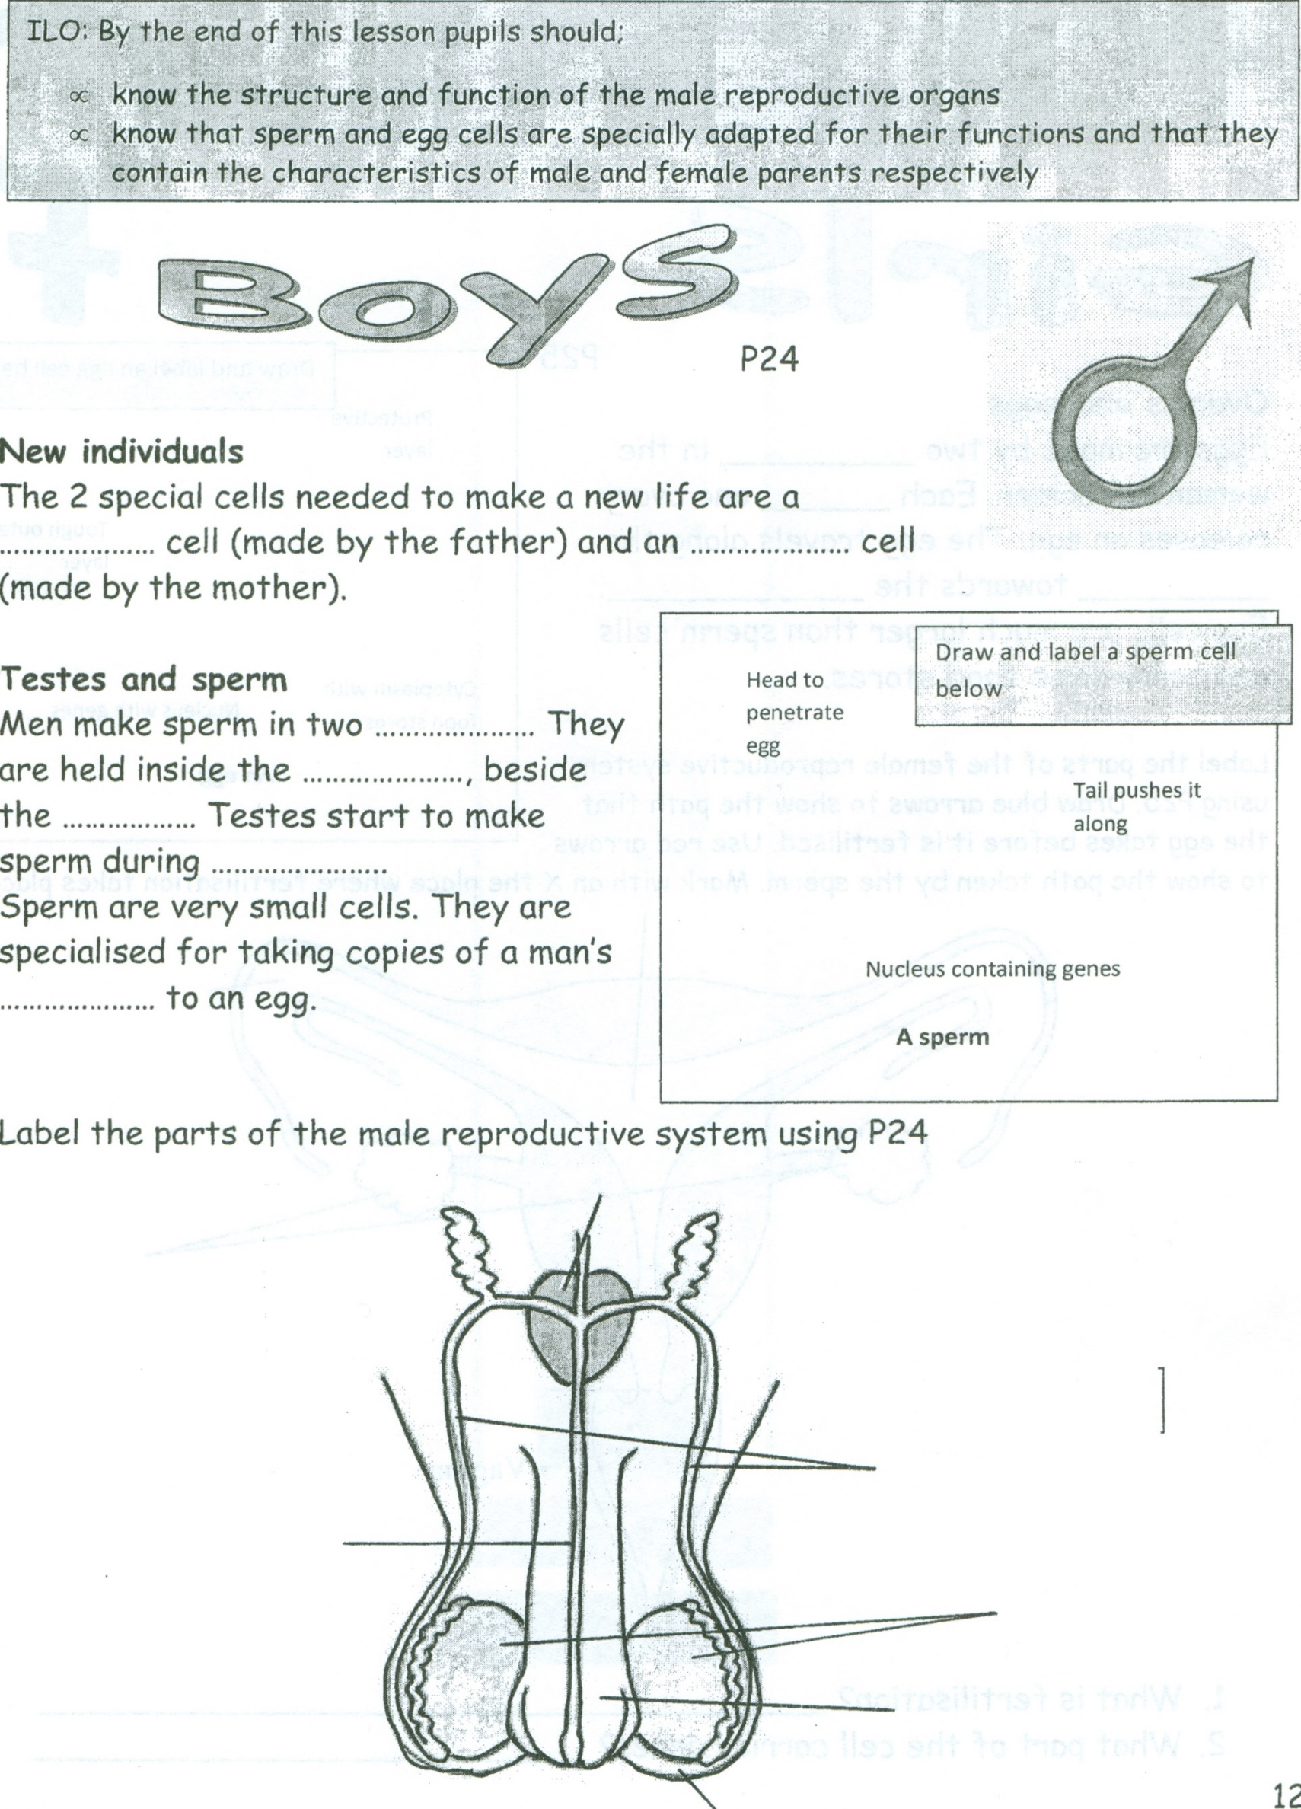

|  |  |
| --- | --- |
| **Structure** | **Function** |
| testes | Tube through which the sperm leave the penis |
| urethra | Adds fluid to nourish the sperm |
| scrotum | Organ that introduces sperm into vagina |
| penis | Carries sperm from the testes to the urethra |
| sperm tube | Sac that holds and protects the testes at slightly lower than body temperature |
| prostate gland | Produce sperm |

1. The Female Reproductive System

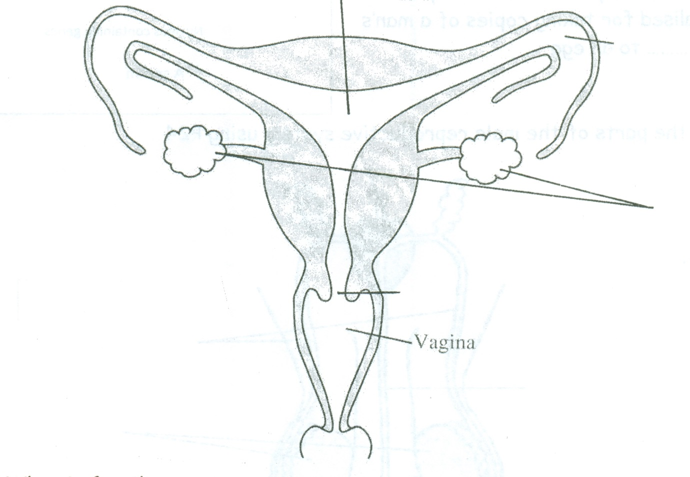

|  |  |
| --- | --- |
| **Structure** | **Function** |
| ovaries | Carries the ova (eggs) to the uterus, fertilisation takes place here |
| oviducts | Will nourish the developing foetus if pregnancy results |
| uterus | The penis places sperm here during sexual intercourse |
| cervix | Produces ova (eggs) |
| vagina | The opening of the uterus, widens during the process of birth |

**Sperm Formation and Pregnancy**

Sperm and egg cells cannot make a baby on their own. They each carry half the number of **chromosomes** needed to start a new life (haploid). **Fertilisation** takes place in the oviducts when the haploid sperm and egg nuclei fuse to give a diploid zygote (a fertilised egg cell).

***Put the following sentences in the correct order of events***

|  |  |
| --- | --- |
| **Sperm travel along the sperm duct** |  |
| **Millions of sperm are released into the vagina** |  |
| **Sperm are made in the testes** | **1** |
| **The egg is now fertilised** |  |
| **One sperm’s nucleus goes into the egg** |  |
| **Sperm swim through the uterus into the oviduct** |  |
| **Hundreds of sperm meet an egg** |  |

[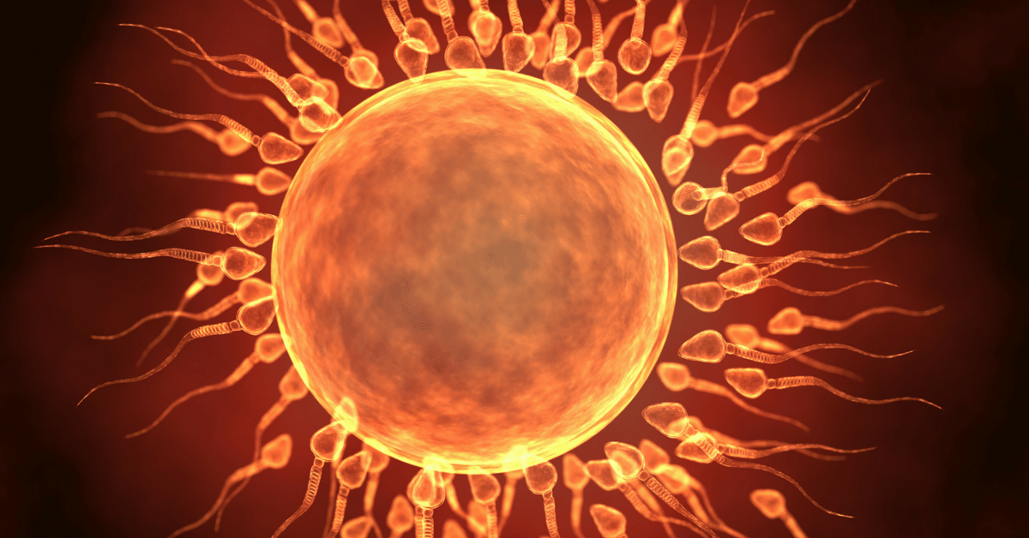](https://www.google.co.uk/url?sa=i&rct=j&q=&esrc=s&source=images&cd=&cad=rja&uact=8&ved=&url=https://twinpickle.com/2016/09/26/identical-twins-fertilized-egg-split/&psig=AOvVaw2ouamTXHXNK7kxrFPfv3k_&ust=1541765877038318)

**Making new cells**

Our body cells are constantly making copies of themselves as we replace damaged or worn out cells. This involves **asexual** reproduction (making exact copies) by a process called **mitosis**. This is also how we grow from a zygote into a ball of cells and eventually into trillions of cells.

To make **sex cells** (gametes), our sex organs (testes or ovaries) produce cells by a special type of cell division called **meiosis**. This has an extra division so that each gamete produced has half the number of chromosomes (haploid).

Your body is constantly replacing old **cells** with new ones at the rate of millions **per** second

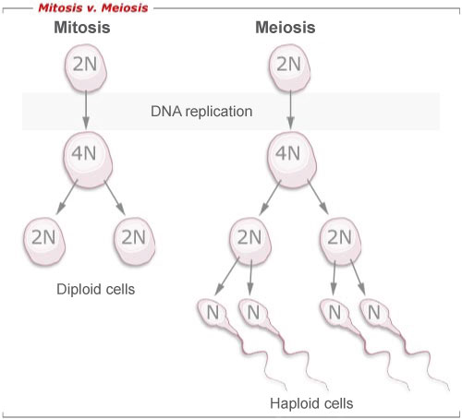

[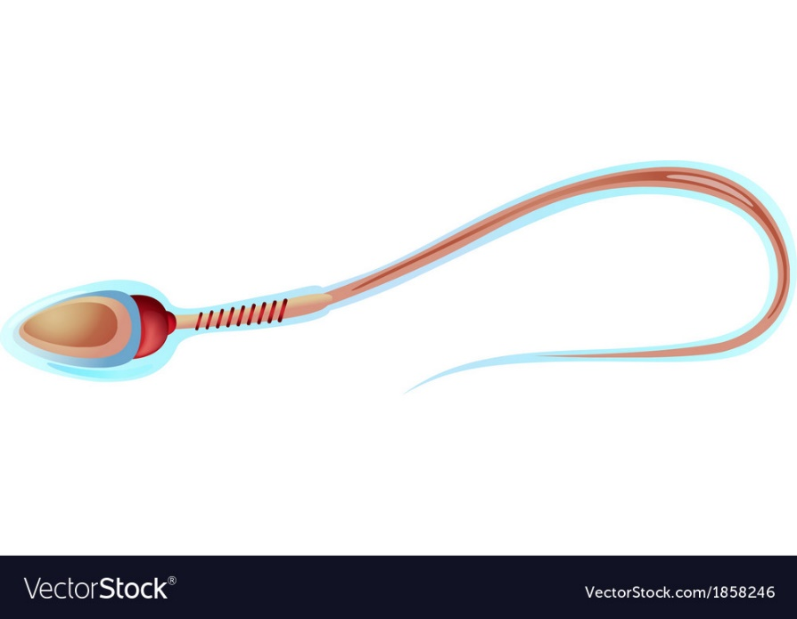](https://www.google.co.uk/url?sa=i&rct=j&q=&esrc=s&source=images&cd=&ved=2ahUKEwj5oKaX0L_eAhWlB8AKHa1NBgIQjRx6BAgBEAU&url=https://www.vectorstock.com/royalty-free-vector/sperm-cell-structure-vector-1858246&psig=AOvVaw3Zix44yQlFs_8hKFyR2CFR&ust=1541588845583998)Sperm cells are specialised cells formed by meiosis in the testes under the influence of the hormone testosterone. They are adapted to their function by having a haploid nucleus, **lots of mitochondria for energy production** and a flagellum (tail) for swimming:

The zygote divides by mitosis many times to form a ball of cells as it travels down the oviduct to the uterus. After implantation in the uterus lining, the embryo then differentiates to produce a variety of tissues and organs.

About once every 28-32 days, an **egg cell** is released from an **ovary**. The egg cell travels down the **oviduct**. If it meets a **sperm cell** swimming in the opposite direction it will be fertilised. The fertilised egg cell continues down the oviduct. As it does this it divides into a ball of cells called an embryo. In the **uterus**, the embryo places itself in the uterus lining. This is called implantation. The uterus lining gives the embryo food and oxygen to grow.

1. The diagram below shows half of the female reproductive system. Cut out the pictures at the bottom of the page and stick them in the right places on the diagram.
2. Write a sentence for each one saying what is happening.
3. On the diagram, label the words in **bold** in the passage.

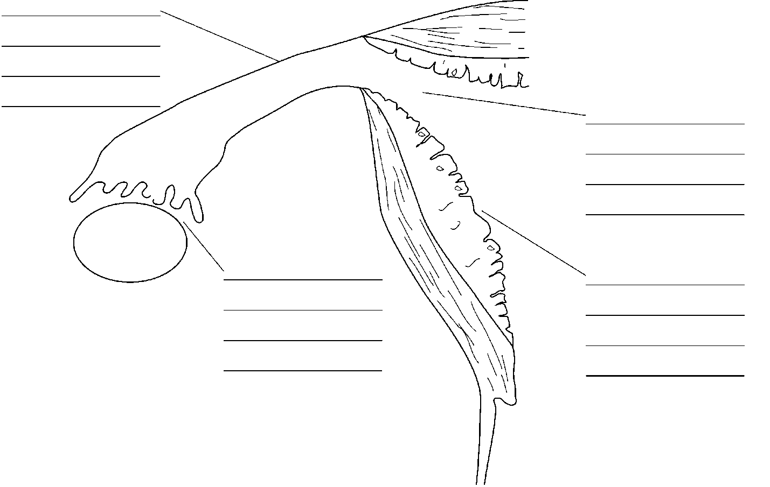



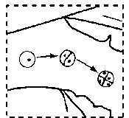 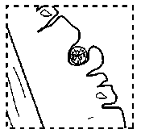 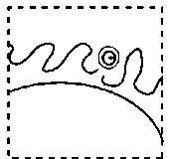 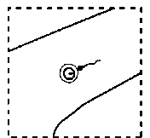

**Embryo development**

When the ball of cells enters the uterus, it sinks into the thick lining that has developed inside the uterus wall, becomes attached and receives nourishment (**implantation**). The cells of the embryo then start to **differentiate**, producing a variety of tissues and organs.

[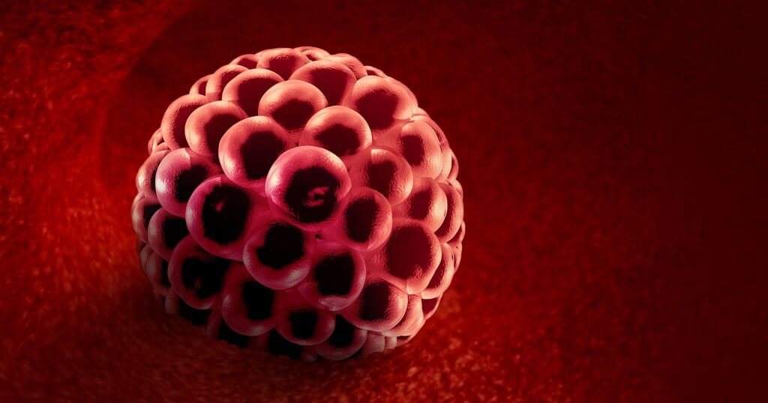](https://www.google.co.uk/url?sa=i&rct=j&q=&esrc=s&source=images&cd=&cad=rja&uact=8&ved=2ahUKEwiF4Jnz6uLeAhWRF8AKHaf3BsgQjRx6BAgBEAU&url=https://www.mamanatural.com/implantation-bleeding/&psig=AOvVaw0QMNWJJbYiKJKz8Uojy67H&ust=1542798607960383)The **placenta** and **umbilical cord** form for the exchange of materials between the mother and the foetus. A membrane, the **amnion**, which is filled with **amniotic fluid**, cushions (protects) the foetus. Useful materials such as **oxygen** and **dissolved nutrients** pass from the mother to the foetus and waste excretory products (including carbon dioxide and urea) pass from the foetus to the mother. These materials move because of diffusion so the placenta is adapted for diffusion by having a large surface area **(the surface area between the uterine wall and the placenta is further increased by small villi (extension) in the placenta that extend into the uterus wall.**

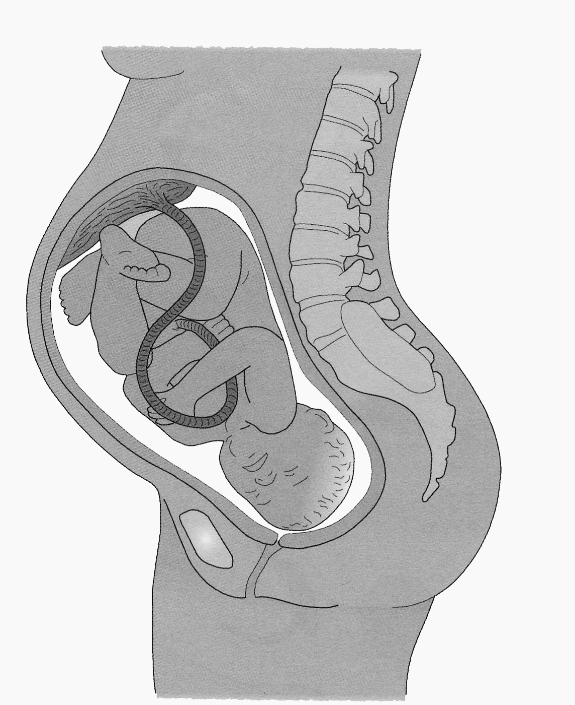

Placenta

Foetus

Umbilical cord

Amniotic fluid

Amnion (sac)

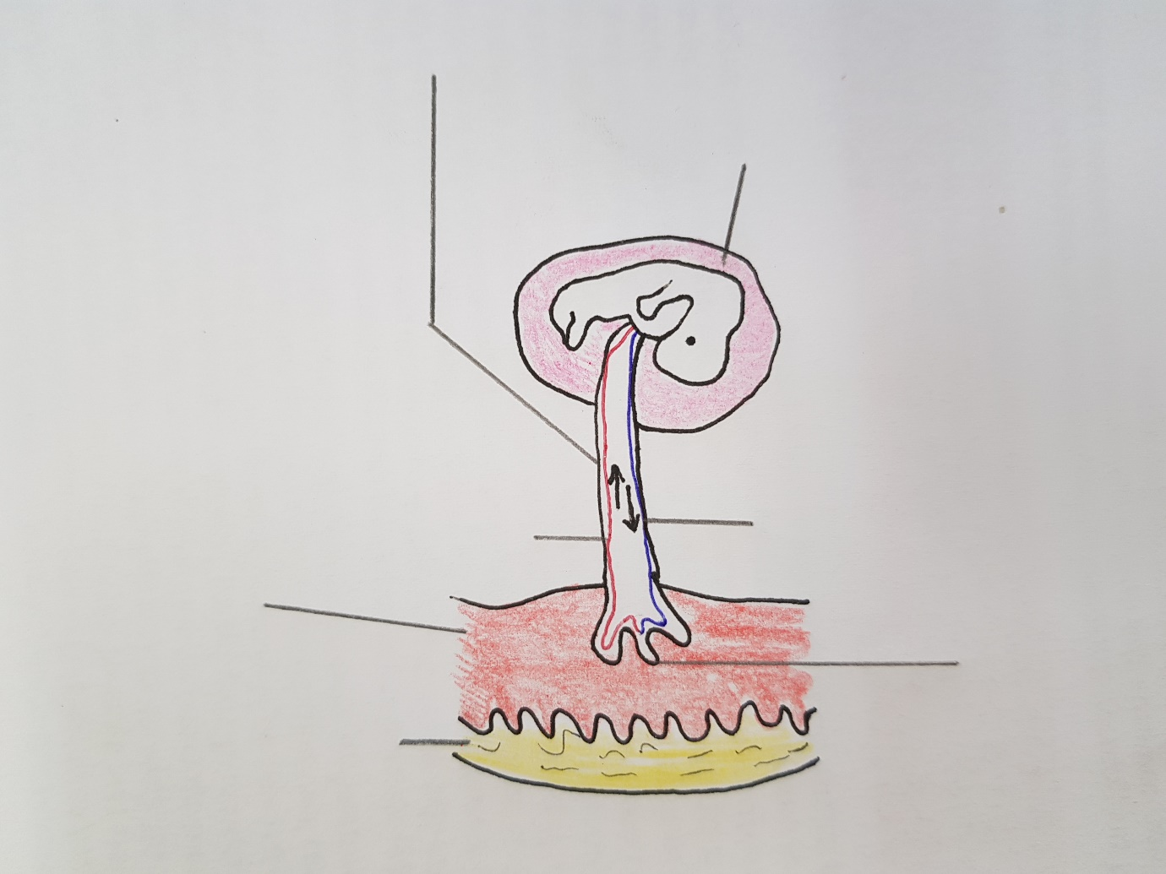

**Fertilisation and development**

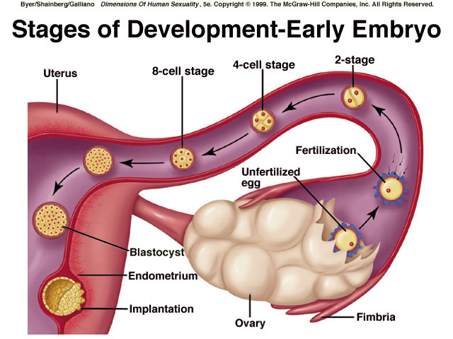

the **zygote** divides by mitosis many times to form a ball of cells as it travels down the oviduct to the uterus;

**fertilisation** takes place in the oviducts when the sperm and the haploid egg nucleus fuse to give a diploid zygote;

after **implantation** in the uterus lining it then differentiates to produce a variety of tissues and organs.

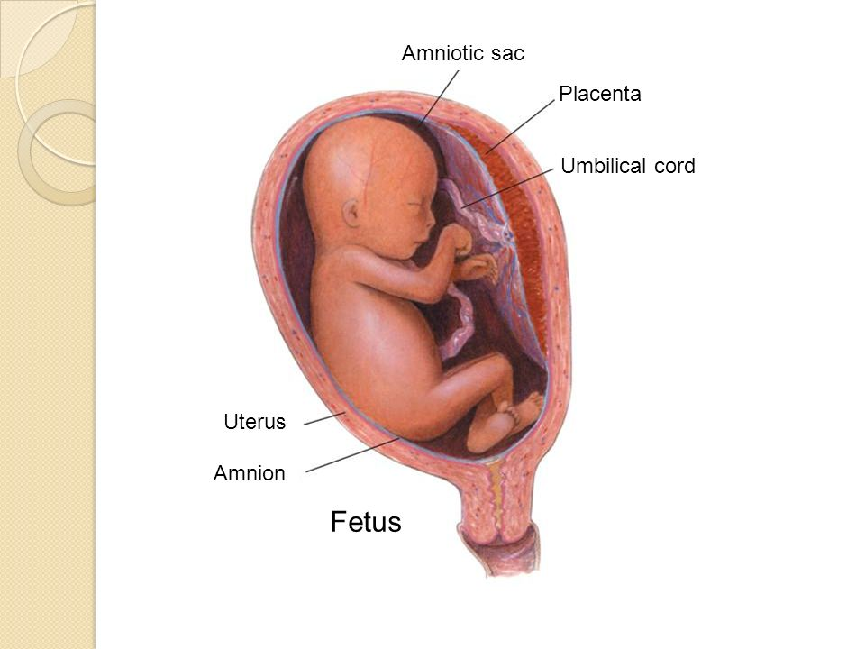

The **placenta** is adapted for diffusion by having a large surface area for exchange of dissolved nutrients, oxygen, carbon dioxide and urea,

the **amnion** and **amniotic fluid** cushion the foetus

Foetus

These substances are carried to or from the foetus in the blood vessels in the **umbilical cord**

[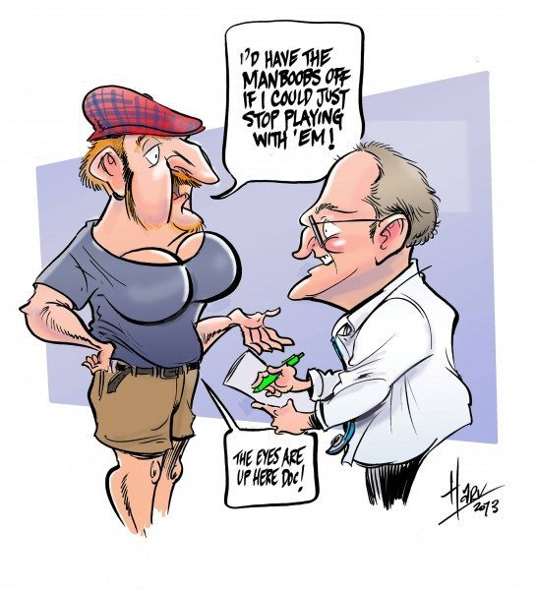](https://www.google.co.uk/url?sa=i&rct=j&q=&esrc=s&source=images&cd=&cad=rja&uact=8&ved=0ahUKEwj0j_Tt_uDXAhWiAMAKHYTHDzEQjRwIBw&url=https://maxedmuscle.com/gym-showdown-testosterone-supplements-vs-testosterone-boosting-food/&psig=AOvVaw2S-SvMgnSBVwLbkkm2uYFb&ust=1511948893518027)**Sex hormones and secondary sexual characteristics**

Hormones are ………………………………………………………………… ……………………………………………………………………..……………………

Males and females have different sex hormones. Males produce ……………………… in their …………………… . Females produce several hormones one of which is …………………………………… (produced by the …………………………). These hormones control the changes we experience during puberty (secondary sexual characteristics).

|  |  |  |
| --- | --- | --- |
| **BOYS** | **BOTH** | **GIRLS** |
|  |  |  |
|  |  |  |
|  |  |  |
|  |  |  |
|  |  |  |

|  |  |
| --- | --- |
| 1. more spots might appear | 1. hair and skin may be more greasy |
| 1. hips become wider | 1. pubic hair starts to grow |
| 1. breasts develop | 1. underarm hair starts to grow |
| 1. voice deepens | 1. shoulders and thighs become stronger |
| 1. menstruation starts | 1. eat more |
| 1. facial hair grows | 1. penis & testes increase in size |
| 1. sperm are produced & released | 1. sweat / perspire more |
| 1. eggs start to be released | 1. mood swings |

**Menstrual Cycle**

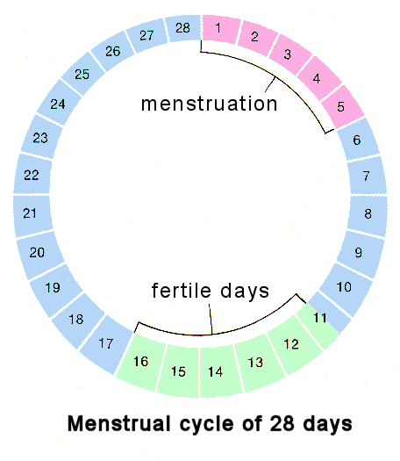

**Day 1 – Period – old blood lining is shed**

**Day 7**

**Day 14**

**Ovulation**

A girl’s periods are part of her menstrual cycle. Each cycle lasts about 28 days.

**The first half of the cycle** – at the start of each cycle;

* An egg starts to mature inside a small pocket of cells
* The uterus gets ready to receive a fertilised egg. The hormone progesterone stimulates the build-up and maintenance of the thick uterine lining.

Ovulation

**Ovulation**

Ovulation is the time when the egg is released from the ovary. This happens when the levels of the hormone oestrogen peaks. The egg enters the oviduct and travels down the tube.

**The second half of the cycle**

* If the egg is *fertilised* the cycle is switched off until after the baby is born
* If the egg is NOT fertilised by a sperm, it dies. The thick lining of the uterus breaks up and is lost with blood through the vagina. This is called ‘having a period’, or menstruation.

**Oestrogen** has 2 main functions in the menstrual cycle: the initial repair and build-up of the uterus wall and stimulation of ovulation.

**Progesterone** is responsible for the build-up and maintenance of the uterus lining.

**Fertility problems (infertility) and their treatment**

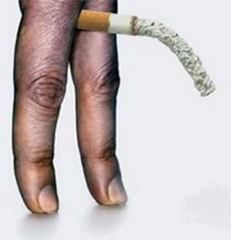Some people have problems that prevent them having children. Reasons include;

* Males may not produce enough ………… or the sperm may not be healthy – can be affect by …………………………………………………………………
* Impotence in males
* Failure of ovaries to produce ………………
* Failure to produce sex **hormones**
* Blocked/twisted ……………………, possibly due to infection
* Complications of some STIs
* The lining of the uterus does not develop properly to enable …………………………… to occur
* The v……………… may be hostile to sperm entering, e.g. the mucus lining may be too thick or too acidic

**Treatment**

**Fertility drugs (hormone treatment)**

These are given to the woman to increase the production of eggs. However, if this is not the problem then ***in-vitro fertilisation (IVF)*** may be necessary.

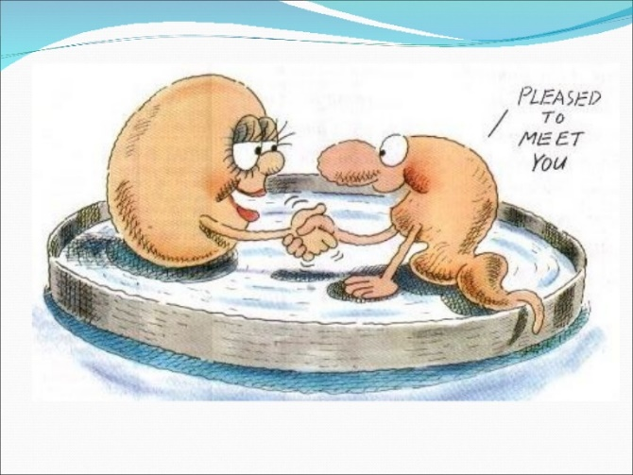

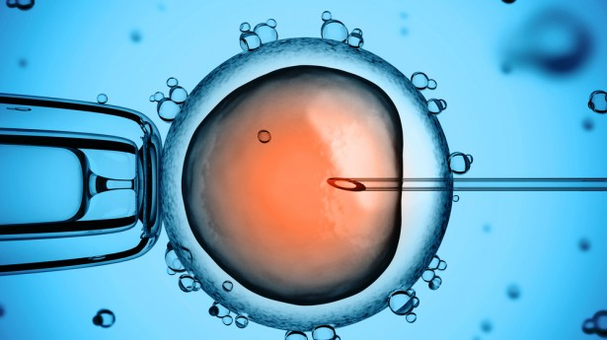**IVF = *in vitro* fertilisation** (in glass).

1. Woman given fertility drug so several eggs are produced
2. Eggs and sperm collected and mixed in the laboratory
3. Following fertilisation, a small number of embryos are placed in mother’s uterus (prepared by hormonal treatment)
4. If successful, embryo(s) will implant

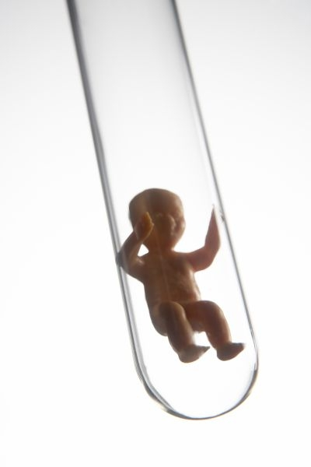**Ethical issues**

Fertility treatment is controversial;

* How long should unused embryos be stored?
* Who owns/has rights to the embryo/donor embryos?
* Spare embryos may be disposed of/destroyed
* Parents may wish to select e.g. gender of child / screened for abnormalities
* Should spare embryos be used for research?
* Religious reasons

**Contraception**

|  |  |  |  |
| --- | --- | --- | --- |
| **Method** | **Explanation** | **Advantages** | **Disadvantages** |
| **Mechanical** |  |  |  |
| Condom  Femidom/female condom | prevents **sperm meeting egg/getting into oviduct**  **(Not** stops sperm getting into body) | Can prevent STIs | Can split  Need one at the time  Temporary |
| Diaphragm/cap | (Cap)  – placed over cervix;  – egg and sperm can’t meet; | Non- permanent  No worries about supply | Doesn’t prevent STIs |
| Coil | placed inside uterus; prevents implantation; |
| **Chemical** |  |  |  |
| (Hormone) implant/**hormone** injection  (Contraceptive) pill  **Morning after** pill | prevents ovulation | Non- permanent  No worries about supply | Doesn’t prevent STIs  May need to take every day (can forget) |
| **Surgical** |  |  |  |
| Vasectomy  (sterilisation) | sperm ducts cut/tied; egg and sperm can’t meet/no sperm in ejaculate **(Not** no sperm produced) | Doesn’t prevent STIs | Permanent  Doesn’t prevent STIs |
| Female sterilisation | oviducts/Fallopian tubes cut/tied;  egg and sperm can’t meet  **(Not** no eggs produced) |
| **Natural** |  |  |  |
| Rhythm method / abstinence | sperm and egg can’t meet/no fertilisation; | Suitable for people with ethical issues regarding contraception | Least reliable |