Unit 2: Body Systems, Genetics, Microorganisms and Health
2.5 Variation and natural selection
Content - CCEA Double Award Biology 2 – Fort Hill Integrated College | Got it | Nearly | Haven’t a clue
2.5 Variation and natural selection
Types of Variation
Can you describe how to investigate variation in living things and display data
using appropriate graphical techniques, including:
- height and length as examples of continuous variation (histogram); and
- tongue rolling and hand dominance as examples of discontinuous variation (bar chart);
Can you demonstrate knowledge and understanding that variation in living organisms has:
- a genetic basis – mutations (random changes in the number of chromosomes or the structure of a gene) and sexual reproduction produce different phenotypes in a population; and
- an environmental basis influencing the development of a phenotype (for example height in humans); and
Natural selection
Can you demonstrate knowledge and understanding of how variation and natural selection may lead to evolution or extinction, including:
- variation in the phenotypes of a population;
- competition for resources often leading to differential survival of the best adapted phenotypes, for example antibiotic resistance;
- surviving phenotypes are more likely to reproduce and pass on their genes to the next generation;
- the theory of evolution as a continuing process of natural selection that leads to gradual changes in organisms over time, which may result in the formation of a new species; and
- extinction of a species over time as a consequence of failure to adapt to environmental change.
Selective breeding
Can you explain selective breeding in food plants and domesticated animals as a process in which:
- humans select individual plants or animals for their desirable genetic characteristics, for example appearance, increased food quantity or quality or disease resistance, and breed them to produce offspring; and
- repeated selection and breeding over many generations causes all the offspring to show the desired characteristic.

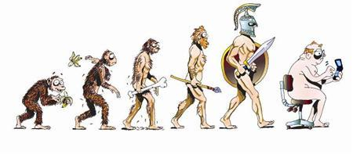
2.5 Variation and natural selection
Types of Variation

Living organisms that belong to the same species usually vary from each other in many ways. There are two main types of variation;
- Continuous – a gradual change in a characteristic across a population e.g. height, weight, hand span – the histogram produced shows a ‘normal distribution’.
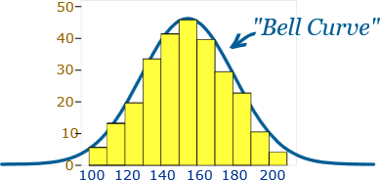
- Discontinuous – ‘either or’ traits – the population can be clearly divided into discrete groups or categories e.g. tongue rolling, hand dominance, blood groups – data presented by a bar chart.
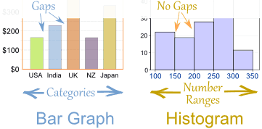
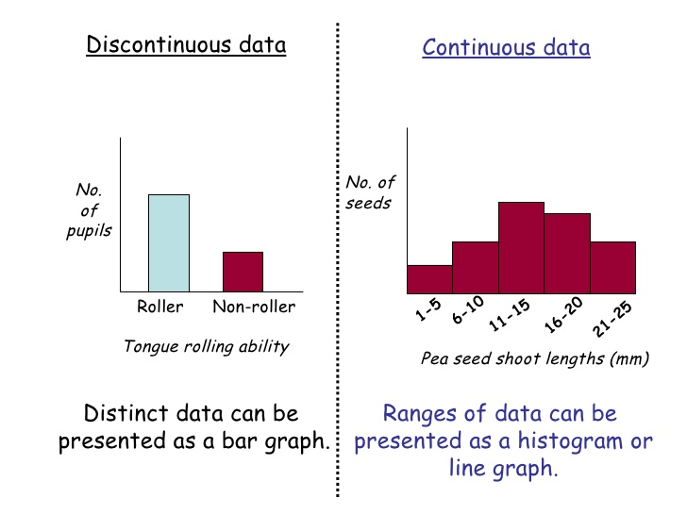

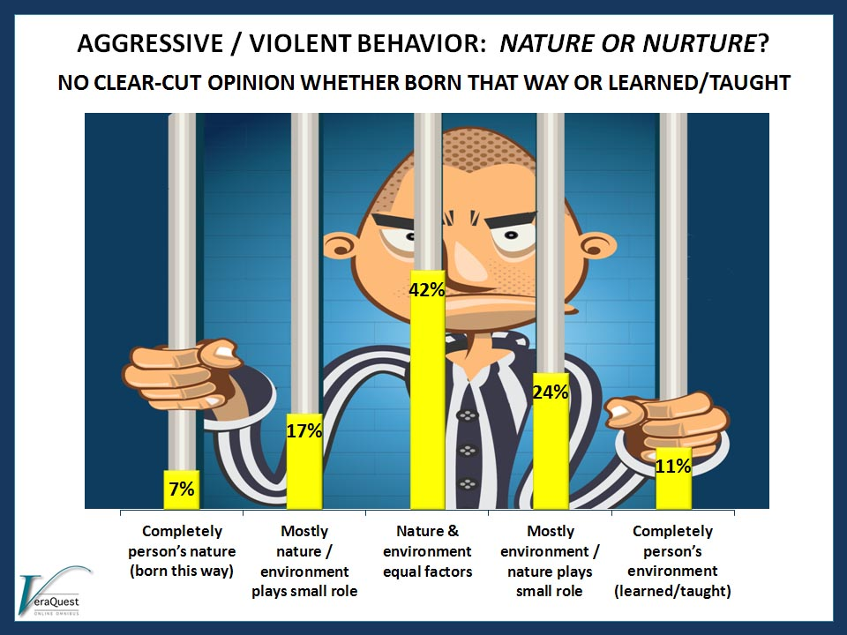
Causes of variation
Variation in living organisms involves …………………… variation and/or variation due to the ………………………………

Genetic variation
This is variation as a result of changes to chromosomes or genes (DNA). Mutations are random changes in the number of chromosomes or type of gene. We have already come across a number of examples:
- Down’s syndrome is caused by …………………………………………………………
- Cystic fibrosis and Huntington’s disease are each caused by a ………………………………………………………………………
Genetic variation is also caused by the process of s…………………… reproduction.

Environmental variation
The environment can also provide variation. While to a large extent height in humans is genetically controlled, the actual height a human grows to will depend on the quality of nutrition.

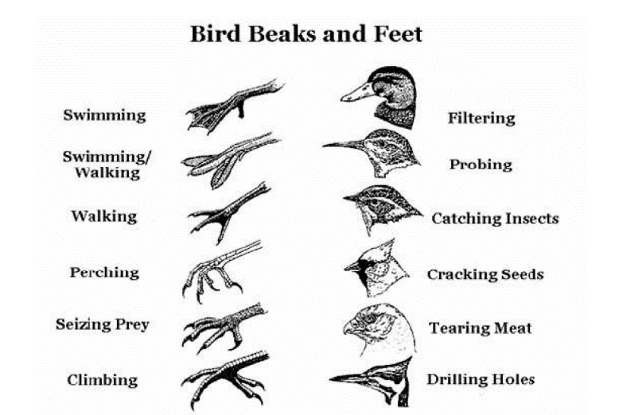
Natural selection
All organisms require adaptations to cope with their environment. These are even more important when organisms compete with each other for resources e.g. food, light, territory, mates, space. This competition ensures that the best adapted individuals will survive, often at the expense of the weaker ones.
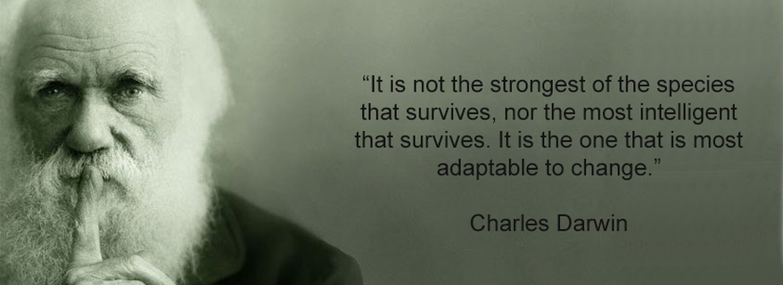
This competition for survival, with the result that the better equipped individuals survive, summaries Charles Darwin’s theory of natural selection:
- There is variation among the phenotypes (individuals) in a population
- If there is competition for resources, there will be a struggle for existence
- The better-adapted phenotypes survive this struggle or competition. This leads to survival of the fittest and these (fittest) individuals are more likely to pass their genes on to the next generation.
- In theory, these gradual changes in organisms over time, may result in the formation of new species; or
- If members of a species fail to adapt to environmental change, the species may become extinct over time.
Antibiotic resistance in bacteria
When bacteria are treated with an antibiotic such as penicillin, most of them are killed. However, a small number (the best adapted phenotypes) may survive, probably because they have a gene (caused by mutation) that provides resistance. Very soon, the resistant bacteria are the only ones remaining, as they are the only ones surviving and passing on their beneficial mutations on to their offspring.

Stage 1  Bacteria reproduce |  |  |  | Stage 2  Treated with antibiotic |  | Stage 3  Offspring of survivors
 |  |  |  |  | These bacteria are killed by the antibiotic
 |  |  |  |  |  |  | Mutated bacteria survive and multiply
Key
 | Normal bacteria
 | Bacteria with a mutation that gives resistance to the antibiotics used in stage 2

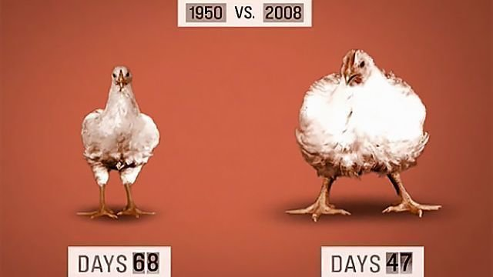
Selective breeding
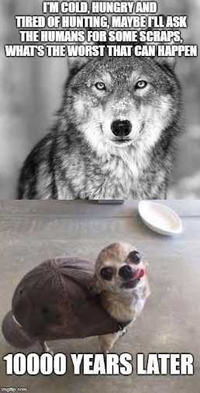
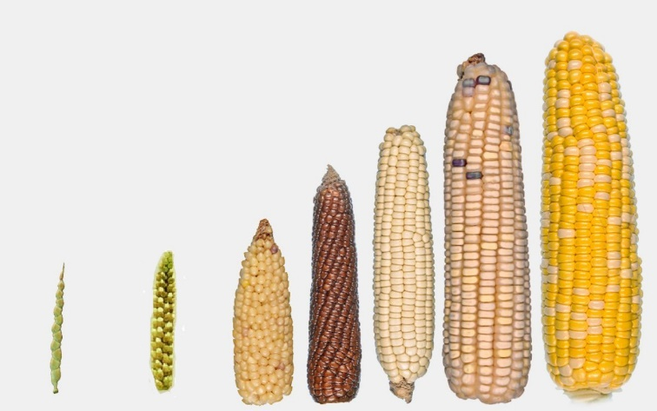
For centuries, people have manipulated the course of natural selection by deliberately selecting particular characteristics or traits in many plants and animals that are of use to us e.g. increased food production, food quality, faster growth, disease resistance, personality (in pets). This is the process of selective breeding (artificial selection). Repeated selection and breeding over many generations causes all the offspring to show the desired characteristic.
