Chemistry Unit C1: Structures, Trends, Chemical Reactions, Quantitative Chemistry and Analysis
C1.2 Bonding
Content - CCEA Double Award Chemistry 1 – Fort Hill Integrated College | Got it | Nearly | Haven’t a clue
C1.2 Bonding
Ionic bonding
Can you describe and explain that an ion is a charged particle formed when an atom gains or loses electrons and a molecular ion is a charged particle containing more than one atom;
Can you define the terms cation and anion;
Can you explain, using dot and cross diagrams, how ions are formed and how ionic bonding takes place in simple ionic compounds, limited to elements in Groups 1 (I) and 2 (II) with elements in Groups 6 (VI) and 7 (VII), the ions of which have a noble gas electronic configuration;
Do you understand that:
- ionic bonding involves attraction between oppositely charged ions;
- ionic bonds are strong; and
- substantial energy is required to break ionic bonds;
Do you recognise that ionic bonding is typical of metal compounds;
Covalent bonding
Can you describe a single covalent bond as a shared pair of electrons;
Can you explain, using dot and cross diagrams, how covalent bonding occurs in H₂, Cl₂, HCl, H₂O, NH₃, CH₄ and similar molecules and label lone pairs of electrons;
Can you draw dot and cross diagrams and indicate the presence of multiple bonds in O₂, N₂ and CO₂;
Can you recognise covalent bonding as typical of non-metallic elements and compounds.
Can you demonstrate knowledge and understanding that a molecule is two or more atoms covalently bonded and that diatomic means there are two atoms covalently bonded in a molecule;
Can you recall that covalent bonds are strong and substantial energy is required to break covalent bonds;
Can you recall that a covalent bond may be represented by a line;
Metallic bonding
Can you demonstrate describe and explain that metallic bonding results from the attraction between the positive ions in a regular lattice and the delocalised electrons.

Bonding
Particles can bond together in three different ways;
- I………………… bonding (between metals and non-metals)
- C………………… bonding (between Non-metals)
- M………………… bonding (in metals only)
- Ionic Bonding
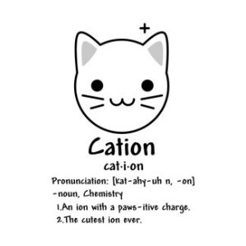
An ion is a ………………….. particle formed when an atom ………………….. or loses …………………... Atoms do this to attain a ………………….. ………………….. configuration giving them full outer shells.
Group I and Group II metals ………………….. electrons to attain full outer shells and in doing so become …………………... Positive ions are called …………………... (paws – ative)
Group VI and Group VII non-metals form full outer shells by ………………….. electrons and so become …………………... Negative ions are called …………………...
A molecular ion is a charged particle containing more than one atom. The Periodic table has a list of some of these on the back.

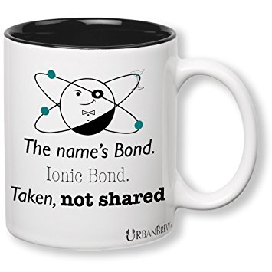
Ionic bonding (a metal + non-metal)
Where to these electrons go or come from? They are ………………….. or ………………….. between metals and non-metals. As the ions created have opposite charges, they then stick together as an ionic ………………….. which is strong and requires a lot of energy to break it.
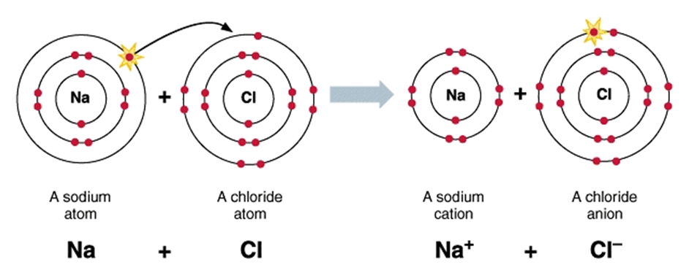

Lithium fluoride

Magnesium oxide

Magnesium fluoride

Sodium sulphide

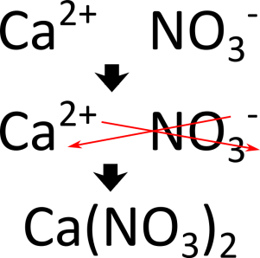
Chemical formulae of ionic compounds
The chemical formula of a compound tells us both the ………………… involved and also the simplest ……………….. of these elements in the compound. The ratio of the elements depends on how many ……………………… are needed to complete the outer shells. For ionic compounds we can work out the formula using the ‘……………. ………. ……..….’ rule. We use the ……………….. number (the number of electrons an atom can lose, gain or share).

What is the chemical formula for the following Ionic compounds?
- Potassium sulphide

- Strontium oxide

- Beryllium bromide

- Iron (III) oxide

- Lithium hydroxide

- Ammonium chloride

 | Ionic compounds (Group I&II with VI&VII) | Explanation
Normal state | Solid (white) | There are strong forces of attraction between ions
Melting points | high
Boiling points | high
Solubility | Most dissolve in water (aq)
Conductivity | Not as Solid  Yes as Molten / Aqueous | Ions are not free to move  Ions carry charge and are free to move when molten or aqueous
Strength | Brittle | Forcing ‘like’ (++ or --) together makes these ions repel, shattering the solid.
Explanation of Ionic properties

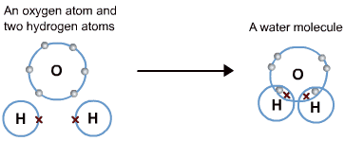
Covalent bonding
Covalent bonding is typical of ……………………………. elements and compounds. In covalent bonding, atoms gain a ………………….. ……………… configuration by ………………………… electrons. A molecule is two or more atoms covalently bonded together. In a diatomic molecule there are ………… atoms covalently bonded together.
A single covalent bond is a ‘shared p……………. of …………………….’. Covalent bonds are ……………… and substantial energy is required to break them. We can explain covalent bonds using ………… and ………….. diagrams. Some molecules can have multiple covalent bonds (e.g. O₂, N₂ and CO₂).
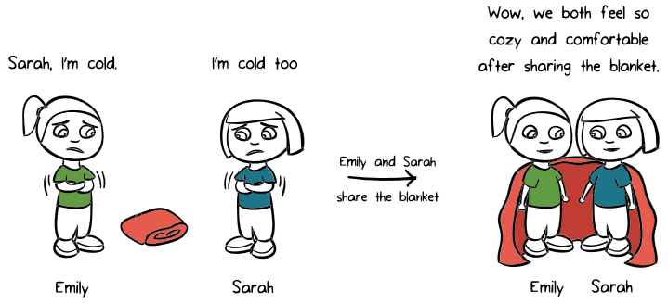

Draw dot and cross diagrams to explain the formation of the following molecules: H₂, Cl₂, HCl, H₂O, NH₃, CH₄, O₂, N₂ and CO₂
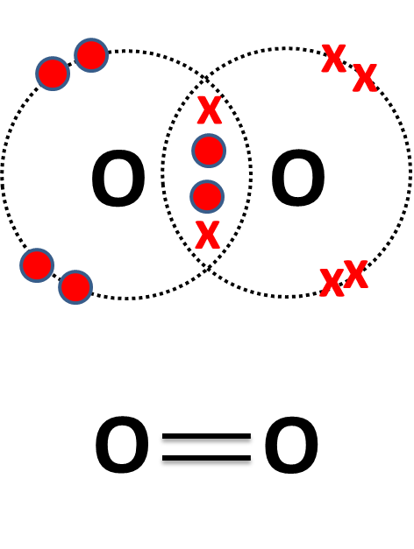

Metallic bonding
Molecules and structures are held together by ………………… There are 3 main types of bonding;
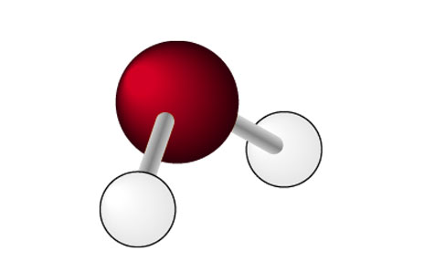
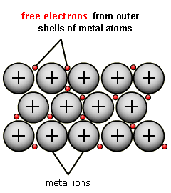
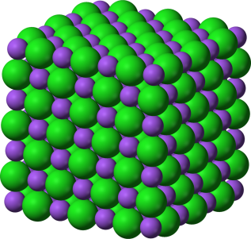

The bonding in a metal is caused by the ……………………… between …………………………… (free) electrons and the positive ions in the structure of the metals. The ions are arranged in ………………………… with the delocalised electrons moving between the layers. This bonding explains the properties of metals;
- high ………………… points as substantial energy is required to overcome the strong metallic bonds between the +ve ions and –ve delocalised electrons
- good ……………………… conductors as the delocalised electrons are free to move and carry charge (even when molten)
- ……………………… (can be hammered into shape) and ………………… (can be drawn into wires) as the layers of ions can slide over each other without disrupting the bonding.

Properties of materials
 | Ionic (Group I&II with VI&VII) | Simple Covalent molecule | Giant Covalent Structures | Metals
Normal state | Solid (white)  Brittle | Gas or Liquid | Solids (C – diamond and graphite) | Solid (except Hg)  malleable
Melting points | High | Low | High | High
Boiling points | High | Low | High | High
Solubility | Most dissolve in water (aq) | Mostly insoluble  (may be soluble in organic solvents) | Insoluble | Insoluble
Conductivity | Doesn’t conduct as solid but if dissolved or molten the ions can move and it does conduct | Never conduct | Don’t conduct except for Graphite which has free electrons | Always conduct (have free electrons)

