Chemistry Unit C1: Structures, Trends, Chemical Reactions, Quantitative Chemistry and Analysis
C1.8 Acids, Bases and Salts
Content - CCEA Double Award Chemistry 1 – Fort Hill Integrated College | Got it | Nearly | Haven’t a clue
C1.8 Acids, Bases and Salts
Indicators and pH
Can you describe the effects of acidic, alkaline and neutral solutions on indicator papers (red and blue litmus papers and universal indicator paper) and the use of a pH meter to give pH data to at least one decimal place;
Can you interpret given data about universal indicator (colour or pH) to classify solutions as acidic, alkaline or neutral and to indicate the relative strengths of acidic and alkaline solutions according to the following classification:
- pH 0–2 strong acid;
- pH 3–6 weak acid;
- pH 7 neutral;
- pH 8–11 weak alkali; and
- pH 12–14 strong alkali;
Can you recall that acids dissolve in water to produce hydrogen (H⁺_{(aq)}) ions;
Can you recall that the higher the concentration of hydrogen ions in an acidic solution, the lower the pH;
Can you recall that alkalis dissolve in water to produce hydroxide (OH– _{(aq)} ) ions; and
Can you demonstrate knowledge and understanding that strong acids and strong alkalis are completely ionised in water, recall examples of strong acids (including hydrochloric acid, sulfuric acid and nitric acid) and recall examples of strong alkalis (including sodium hydroxide and potassium hydroxide).
Can you recall that weak acids and weak alkalis are partially ionised in water, recall examples of weak acids (including ethanoic acid and carbonic acid) and recall examples of weak alkalis (including ammonia);
Can you explain dilute and concentrated in terms of the amount of substances in solution;

Reactions of acids
Can you describe neutralisation as the reaction between the hydrogen ions in an acid and the hydroxide ions in an alkali to produce water and recall the ionic equation as:
H⁺(aq) + OH–(aq) → H₂O(l)
Can you describe how to investigate the temperature change during neutralisation and recall that neutralisation reactions are exothermic (heat is given out);
Can you recall that a base is a metal oxide or hydroxide that neutralises an acid to produce a salt and water and that an alkali is a soluble base;
Can you demonstrate knowledge and understanding of and write observations on and equations for the general reactions of hydrochloric, sulfuric and nitric acids with:
- metals;
- bases;
- carbonates; and
- hydrogencarbonates;
Can you describe how to test for hydrogen gas: apply a lighted splint and a popping sound results; and
Can you describe how to test for carbon dioxide: limewater (calcium hydroxide solution) will change from colourless to milky if the test is positive.
Salts
Can you recall that a salt is a compound formed when some or all of the hydrogen ions in an acid are replaced by metal ions or ammonium ions;
Can you demonstrate knowledge and understanding that most Group 1 (I), Group 2 (II), aluminium and zinc salts are white and if they dissolve in water they give colourless solutions, and that transition metal salts are generally coloured;
Can you explain the importance of safety in the laboratory to assess potential risks, including the hazards associated with chemicals labelled with the GHS/CLP international chemical hazard labelling (including toxic, corrosive, flammable, explosive and caution); and
Can you describe how to investigate the reactions of acids, including temperature
changes that occur (Prescribed Practical C1).

Indicators and pH
We can identify if a chemical is acidic, alkaline or neutral using …………………… papers or pH meters.
Red and blue litmus paper
 | Acid | Neutral | Alkali
Red litmus
Blue Litmus

Universal indicator
pH | 0 | 1 | 2 | 3 | 4 | 5 | 6 | 7 | 8 | 9 | 10 | 11 | 12 | 13 | 14
Colour with universal indicator | Red |  |  | Orange |  | Yellow |  | Green | Green/blue |  | Blue |  | Purple
Strength | Strong Acid |  |  | Weak acid |  |  |  | Neutral | Weak alkali |  |  |  | Strong alkali
Examples | hydrochloric acid (HCl), sulfuric acid (H₂SO₄) and nitric acid (HNO₃) |  |  | ethanoic acid and carbonic acid |  |  |  | Water | Ammonia (NH₃) |  |  |  | sodium hydroxide (NaOH) and potassium hydroxide (KOH)

pH meters
Digital pH meters are more accurate and precise as they give data to at least one decimal place.

Acids dissolve in water to produce hydrogen (H⁺_{(aq)}) ions (the higher the concentration of hydrogen ions in an acidic solution, the lower the pH)
Acid | Formula | Positive ion | Negative ion
Hydrochloric acid
Sulfuric acid
Nitric acid
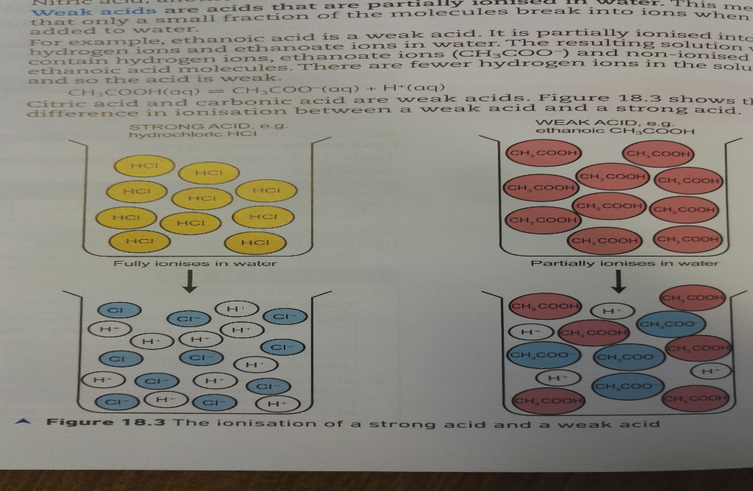
These strong acids and strong alkalis are completely ionised in water. Weak acids and weak alkalis are partially ionised in water;

Alkalis dissolve in water to produce hydroxide (OH– _{(aq)}) ions
Alkali | Formula | Positive ion | Negative ion
Sodium hydroxide
Potassium hydroxide
Ammonia (NH₃) is a gas. When it reacts with water it produces hydroxide ions, so it is an alkali.
NH_{3 (g)} + H₂O _{(l)} NH₄⁺ _{(aq)} + OH⁻ _{(aq)}
Dilute and concentrated acids
A concentrated acid contains a large number of acid particles dissolved per unit volume.
A dilute acid contains a small number of acid particles dissolved per unit volume
The unit of concentration is moldm⁻³

Weak acid e.g. ethanoic CH₃COOH
Strong acid e.g. Hydrochloric HCl

partially ionises in water
fully ionises in water

Definitions
Acids dissolve in water to produce hydrogen (H⁺_{(aq)}) ions
Alkalis dissolve in water to produce hydroxide (OH– _{(aq)}) ions
A Base is a metal oxide or hydroxide that neutralises an acid to produce a salt and water (alkali are a soluble bases)
A Salt is a compound formed when some or all of the hydrogen ions in an acid are replaced by metal ions or ammonium ions (Group 1 (I), Group 2 (II), aluminium and zinc salts are white and if they dissolve in water they give colourless solutions, and that transition metal salts are generally coloured)

Chemical tests for gases;
- Hydrogen - apply a lighted splint and a popping sound results
- Carbon dioxide – bubble the gas through limewater (calcium hydroxide solution) If the gas is CO₂, the limewater will change from colourless to milky
- Oxygen – relights a glowing splint
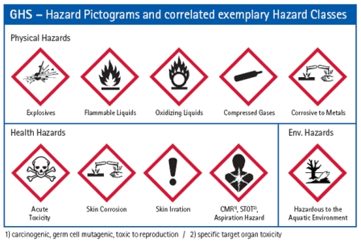
- Water – Add to anhydrous copper(II) sulfate (changes from white to blue with water)

toxic, corrosive, flammable, explosive and caution
Reactions of acids
Write observations on and equations for the general reactions of hydrochloric, sulfuric and nitric acids with:
- metals;
- bases;
- carbonates; and
- hydrogencarbonates;

Acids + Metals (exothermic - )
If a metal reacts with an acid, it always produces a;

Metal + Acid Salt + Hydrogen

e.g. Magnesium + Hydrochloric acid Magnesium chloride + Hydrogen

……………………………………………………………………………………………………………………………
(Observations – grey solid magnesium disappears, colourless solution produced, heat released, …………………..)

Zinc + Sulphuric acid …………………………………………… + …………………………

……………………………………………………………………………………………………………………………
(Observations – grey solid zinc disappears, colourless solution produced, heat released, …………………..)

Acids + Bases Neutralisation (exothermic - )
Neutralisation is the reaction between the hydrogen ions in an acid and the hydroxide ions in an alkali to produce water.
The ionic equation is:
H⁺_{(aq)} + OH–_{(aq)} → H₂O_{(l)}

Acid + Base (alkali) Salt + Water

e.g. Hydrochloric acid + Sodium hydroxide Sodium chloride + Water

……………………………………………………………………………………………………………………………
(Observations –colourless solution remains, heat released)

Sulphuric acid + Zinc oxide …………………………………………… +

……………………………………………………………………………………………………………………………
Copper (II) oxide + sulfuric acid copper (II) sulphate + water

……………………………………………………………………………………………………………………………
(Observations – ……………… solid disappears, ……………… solution produced)

Acids + Carbonates (Hydrogencarbonates)

Acid + metal carbonate Salt + Water + Carbon dioxide

Acid + metal hydrogencarbonate Salt + Water + Carbon dioxide

e.g. hydrochloric acid + calcium carbonate calcium chloride + water + carbon dioxide

……………………………………………………………………………………………………………………………
(Observations – solid white calcium carbonate ………………………, colourless solution produced, heat released, …………………..)

nitric acid + sodium hydrogencarbonate …………………………………… + water + carbon dioxide

……………………………………………………………………………………………………………………………
(Observations – solid white sodium hydrogencarbonate ………………………, heat released, colourless solution produced, …………………..)

